CS 1632 – DELIVERABLE 2: Unit Testing Ruby Rush

Zachary Pixley

zpixley

<https://github.com/zpixley/D2.git>

Summary and Testing Concerns

When first approaching this assignment, my main concern was identifying all the different ways each method can be tested to ensure that it functions properly. For many methods, there are an overwhelming amount of tests that could possibly be created, so something that I learned to do throughout completing the assignment was determining how to prioritize tests that are more important than others. It was also very difficult at times to figure out how to correctly stub a method. Often times I wanted to create a stub method that fully mimicked the behavior of the original method, but I was unable to figure out how to do that. That caused me to create more objects than necessary in order to use all the methods I needed to test.

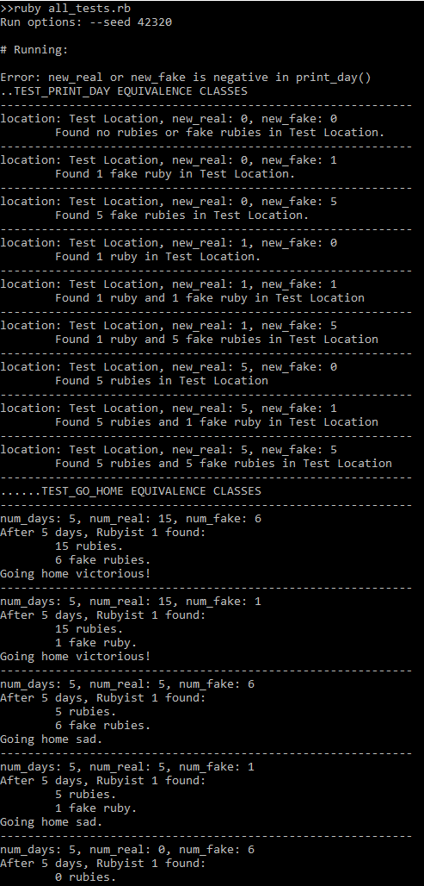Executed Unit Tests  
